# Architectural Thinking

The opposite of system thinking, architectural thinking is a way of composing a meaningful solution to a problem given the abstract assemblages. After disassembling the possible subsystems for this 911 project using system thinking, the architectural thinking combines those subsystems into what would be a fully functioning 911 subsystem.

From the artist's illustration shown in Fig. 1, we need to determine whether data and/or control will be passed, to whom they will be passed to make the system work according the requirement. We could see from that figure that the 911 subsystem will include the operator manager, supervisor manager, database manager, database, Google Map API, 911-EF MyAPI to connect to EF Subsystem and an 911-CMO MyAPI to connect to the CMO system, which is separately build.

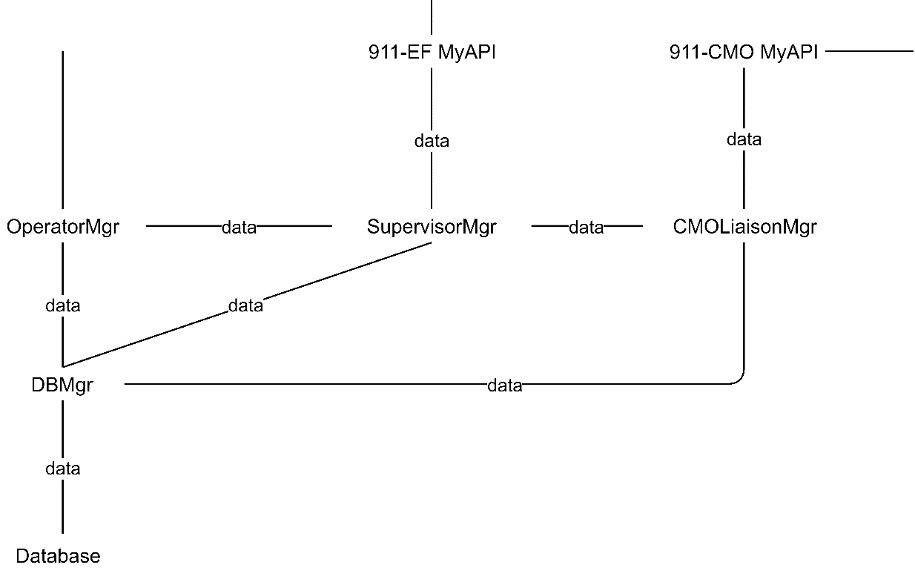

911 Subsystem will follow the following crisis classification in terms of impact of crisis area and how serious the crisis is. The classification will be from lowest to highest impact: Monkey, Wolf, Tiger, Demon, Dragon, God. The call handler will be manned by the operators, who will directly liaise with the caller and gather the data from the conversation to be put into the handler. If the data provided show signs of crisis, the supervisor manager will allow supervisors to receive the data from the call handler, analyse the data using current and past reports.

Should the crisis be Monkey level which indicates a prank call, Supervisor will send the data to Operator using Supervisor Manager.  If the crisis level is classified to be either Wolf or Tiger, Supervisor Manager will send the data to EF subsystem using 911-EF MyAPI. If crisis level is classified Demon and above, the Supervisor Manager will send the data to CMO Liaison Manager who will then send the data to CMO subsystem using MyAPI. The database handles all requests from the call handler and supervisor manager including requests to select, enter, or update data.